Task 5

1. Chat GPT

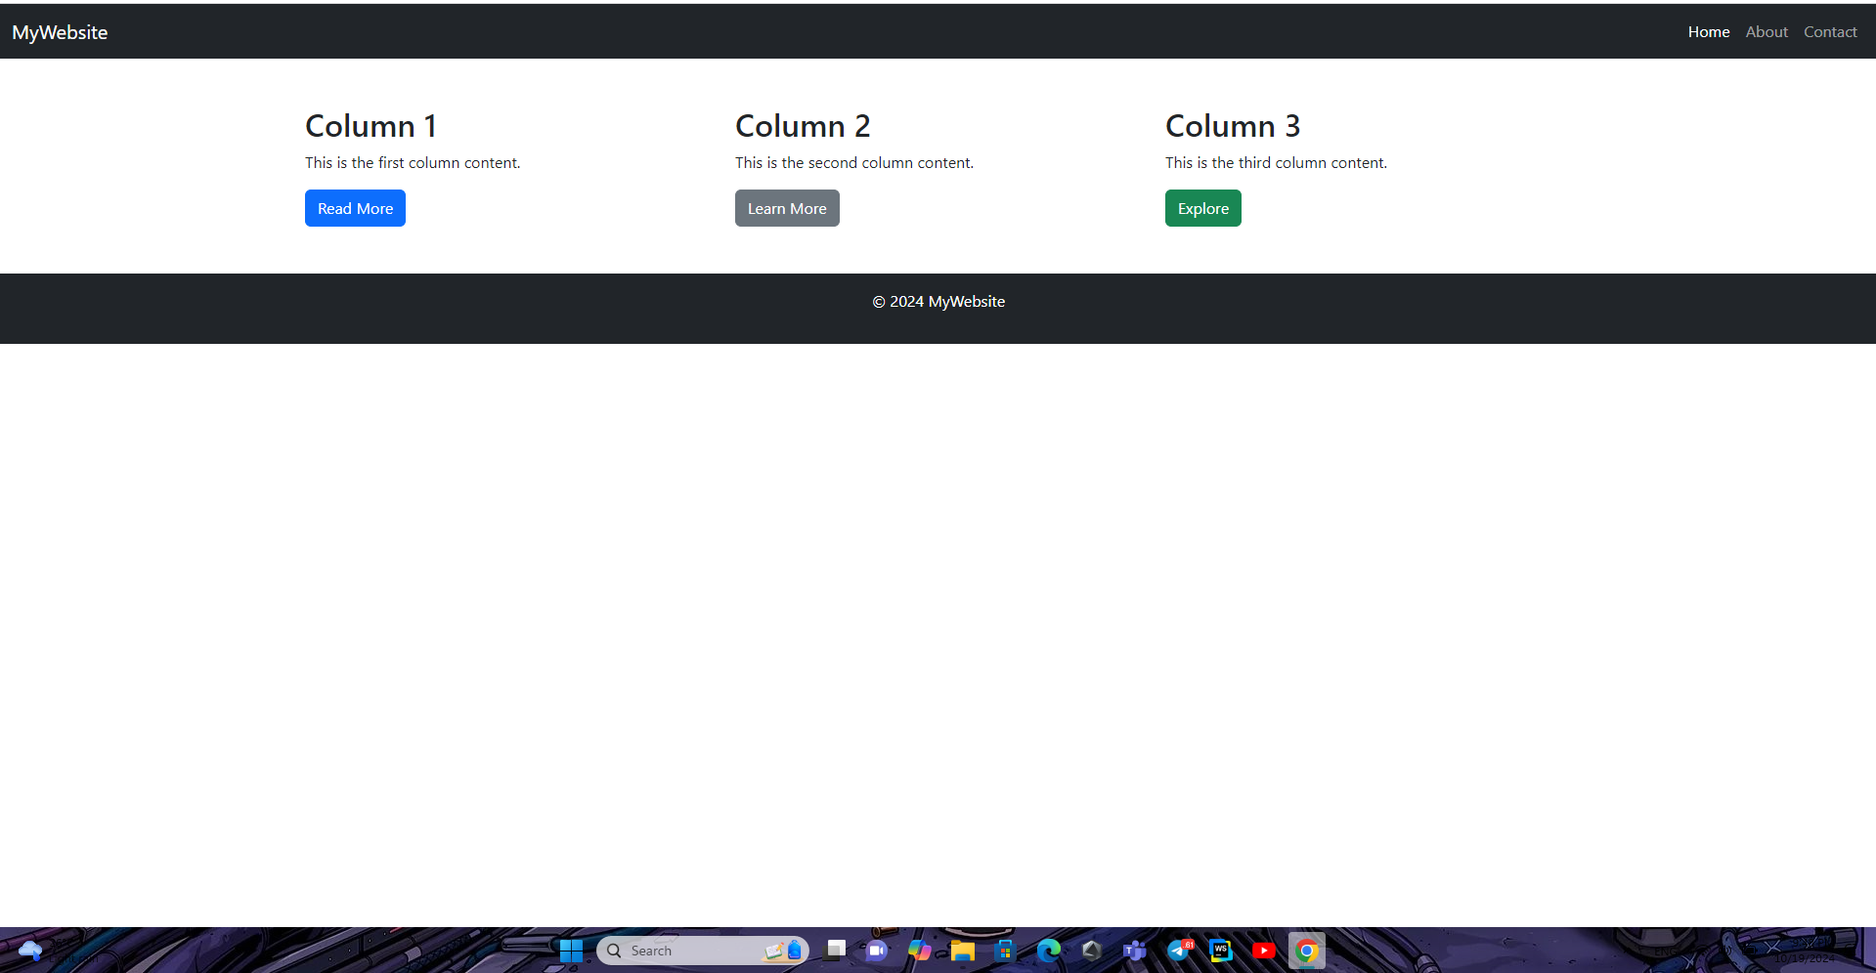

2. Gemini



Both follow the prompt with good result.